California Agriculture Takes Flight: A Guide to Drone Spray Pilot Certification
May 29, 2025
Drone use in agriculture is rapidly expanding across the United States. While drones were initially adopted for imagery, vegetation indices, and hotspot detection for variable rate applications, their role is evolving. Increasingly, drones are being used for chemical applications in crop production, a trend that is gaining momentum in key agricultural regions such as the Salinas Valley.
Aerial spraying has traditionally been used to address issues such as wet fields or tall crops that impede tractor access. Manned aircraft, particularly helicopters, once provided these functions, but their employment is waning due to pilot shortages, safety risks, insurance costs, and legislative limits. In contrast, drones provide a safer, more accessible, and cost-effective solution, particularly for intensive, high-value specialty crops under heavy insect and weed pressure.
As demand grows, local production operations, agronomy service providers, and industry are actively seeking certified individuals to fill this workforce gap. If you're interested in joining this growing field, it's essential to understand the certifications required to legally operate drones for pesticide applications.
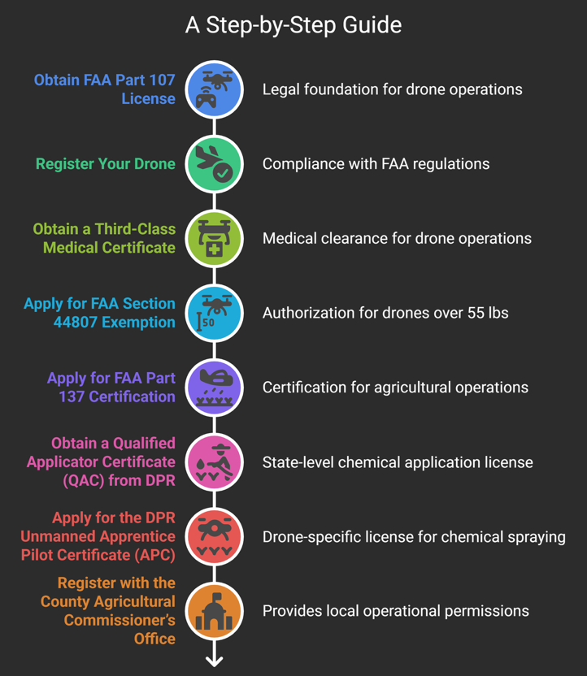
Step by Step Certification Process
To operate drones legally and safely in agricultural spraying, you must complete a series of certifications through both federal and state agencies. Below is a step-by-step roadmap to help you navigate this process.
Step 1: Obtain FAA Part 107 License
The first step toward becoming a certified drone spray pilot is securing the FAA Part 107 Remote Pilot Certificate. This license allows you to operate drones for commercial purposes within U.S. airspace.
Eligibility:
- Must be at least 16 years old.
- Must be able to read, write, and understand English.
Steps:
- Create a profile on the Integrated Airman Certification and Rating Application (IARCA) website to receive an FAA Tracking Number (FTN).
- Schedule and pass the Part 107 exam at an approved testing center.
Once you have your Part 107 license, you can legally fly drones commercially but for spraying pesticides, there’s more to do.
Step 2: Register Your Drone
With your FAA Part 107 license in hand, the next step is to register your drone. Proper registration is a legal requirement for all commercial drone operators.
- For drones under 55 lbs., register online via the FAA Drone Zone with the drone’s serial and manufacturer numbers.
- For drones over 55 lbs.
  - Complete forms 8050-1, notarized Affidavit of Ownership and aircraft bill of 8050-2.
  - Mail documents and a $5 fee to FAA’s Aircraft Registration Branch.
Step 3: Obtain a Third-Class Medical Certificate (Required for drones over 55 lbs.)
This certification ensures that the pilot meets FAA medical standards for commercial drone operations.
Steps:
- Complete the application on MedXPress.
- Schedule an exam with an FAA-designated Aviation Medical Examiner (AME).
- Undergo a physical exam and submit any necessary medical documentation.
- Upon passing, receive your Third-Class Medical Certificate.
Step 4: Apply for FAA Section 44807 Exemption (for drones >55 lbs.)
This exemption allows for the legal operation of drones over 55 lbs., including payload.
Requirements include:
- Operator details and drone specifications.
- Details of the Chief Supervisor of Operations and Pilot-in-Command.
After receiving this exemption, you'll be ready to apply for certification to use drones specifically for agricultural spraying

Step 5: Apply for FAA Part 137 Certification (Agricultural Operations)
This certification officially authorizes your drone operations for agricultural chemical applications.
Steps:
- Complete FAA Form 8710-3.
- Submit the form along with the 44807 exemption approval, and your Third-Class Medical Certificate.
Now that you're federally certified for pesticide application by drone, the next step involves meeting California’s state-level pesticide application requirements.

Step 6: Obtain a Qualified Applicator Certificate (QAC) from DPR
The California Department of Pesticide Regulation (DPR) requires individuals applying restricted-use pesticides to hold a QAC or QAL license.
Eligibility:
- Must be at least 18 years old.
Application Process:
- Download the QAC application from the CA DPR website.
- Select Laws, Regulations, and Basic Principes in section C and Plant Agriculture in section D.
- Mail the completed application with a payment of $320 to
Department of Pesticide Regulation,
Cashier MS-4A PO Box 4015,
Sacramento, CA 95812-4015.
- Pass both required exams with a minimum score of 70%.
Once certified, you're one step closer but a special drone-specific license is still needed for pesticide spraying by air.
Step 7: Apply for the DPR Unmanned Apprentice Pilot Certificate (APC)
This certificate is required in California for any individual applying pesticides using an unmanned aircraft system.
Steps:
- Complete the Pest Control Aircraft Pilot Certificate Application (select “Unmanned Apprentice”).
- Attach a copy of your
  - FAA Part 107 certification
  - Approved 44807 exemption
  - FAA part 137 certification
  - Medical certificate
  - QAC
- Submit a $265 fee.
- Pass the “Certification Exam” by scoring a minimum of 70%.
Once you’ve secured this certificate, you're almost ready to operate with just one final legal step remains.
Step 8: Register with the County Agricultural Commissioner’s Office
You must register annually with each county where you intend to conduct pesticide applications. This involves a registration fee and provides legal permission to operate locally.
Exam Preparation resources
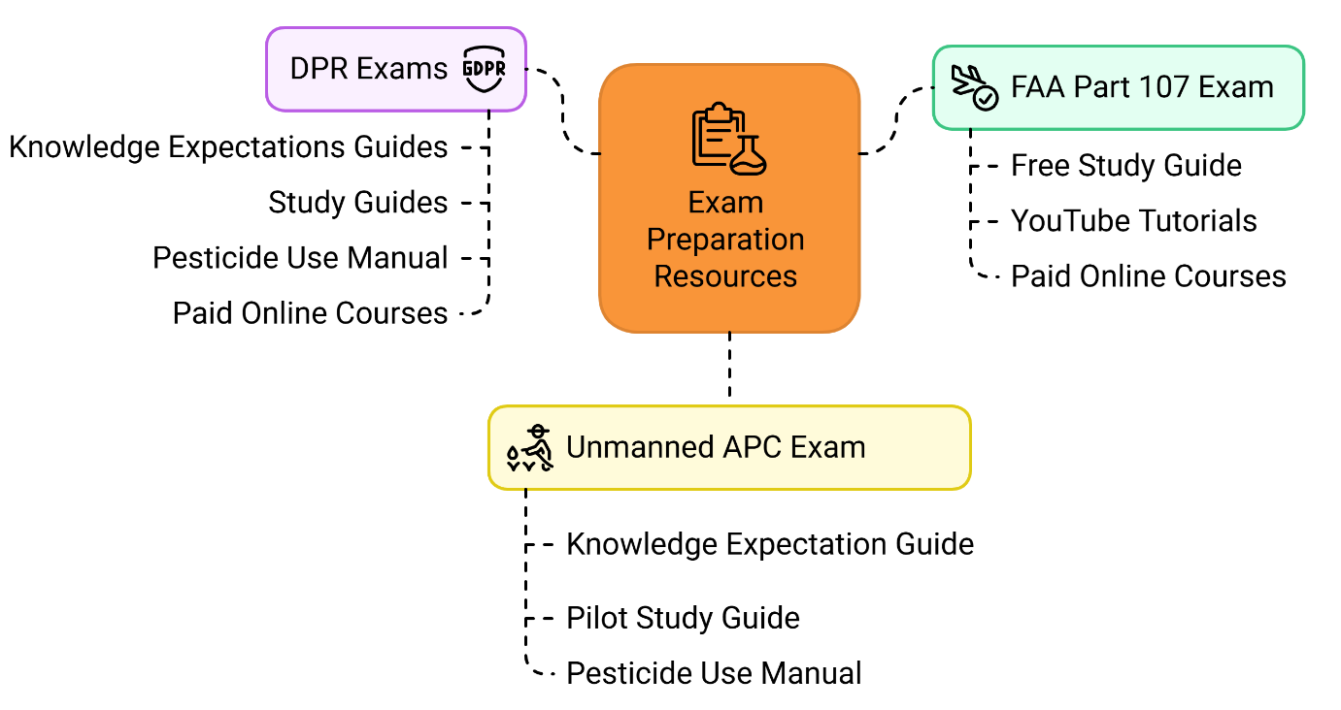
Preparing for multiple exams can be daunting, but many resources are available to help you succeed. Here’s a guide to help you get ready.
- FAA Part 107 exam: This exam tests knowledge of airspace regulations, factors affecting drone performance (such as weather), safety, and emergency procedures. Preparation resources:
  - Review the free Small UAS Study Guide provided by FAA.
  - Utilize free video tutorials on YouTube to gain the necessary knowledge and successfully pass the exam.
  - Paid online courses are also available such as by Pilot Institute.
- DPR’s Laws, Regulations, and Basic Principles exam and “Plant Agriculture Pest Control” exam: These exams cover California’s laws and regulations regarding pesticide registration, sale, and usage to ensure the safe and legal handling of restricted chemicals. To prepare for the exams:
  - DPR provides knowledge expectations guides for both Laws, Regulations, and Basic Principles, and Plant Agriculture exams that help understands and gauge the scope and syllabus of the exams.
  - DPR recommends “Laws and Regulations” study guide to prepare for the exam.
  - DPR also recommends The Safe and Effective Use of Pesticides by the University of California Integrated Pest Management (UC IPM), available for purchase at $60.
  - Private paid online courses are also available to guide and prepare for the examinations.
- DPR Unmanned Apprentice Pilot Certificate (APC) Exam: This exam assesses knowledge of factors affecting pesticide effectiveness, safe chemical handling, drift risks, and aerial application equipment and techniques. For more information please,
  - Go through Exam Knowledge Expectation guide for the Unmanned APC Certification.
  - There’s a Pest Control Aircraft Pilot Study Guide, which is freely accessible as a downloadable pdf manual. It covers the information for the APC exam.
  - DPR recommends The Safe and Effective Use of Pesticides by the University of California Integrated Pest Management (UC IPM), available for purchase at $60.
Building the Drone Pilot Pipeline: Local Stories and Support
Becoming a certified drone spray pilot can be challenging due to the fragmented nature of resources and the complexity of regulatory compliance. Jose Aguilar, the first registered drone spray pilot in Monterey County, shared his story of navigating this process. Starting as a Pest Control Advisor (PCA), he saw the need for aerial spraying and pursued the FAA Part 107 and DPR certifications, ultimately becoming a Journeyman Pilot. Aguilar emphasized the lack of formal training and the value of institutional support. In response, the University of California, Santa Cruz launched a Drone Pilot Training Program focusing on agricultural and environmental applications. UC Cooperative Extension (UCCE) also provides guidance to aspiring drone professionals.
Need Help or Have Questions?
This process can be complex, and regulations may change. We’ve worked to simplify it, but if you find discrepancies or have questions, please don’t hesitate to reach out to:
Paramveer Singh
Ag Tech Advisor, UC Cooperative Extension, Salinas, CA
📧 psbsingh@ucanr.edu | 📞 (831) 214-8621

